St Barnabas Jericho Advent Course 3
A Tale of Two Cities: Babylon and the New Jerusalem

1. A Tale of Two Cities
- Babylon and Jerusalem in biblical tradition
- Babylon and New Jerusalem in Revelation’s story
- Babylon and New Jerusalem: similarities and contrasts

2. Babylon (Rev 17–18)
- Revelation 17 as ‘unveiling’ (apokalupsis)
- Characterization of Babylon (Rev 17:1–6)
- Who/what is Babylon for John? (Rev 17:9–14)
- Who/what is Babylon for us?

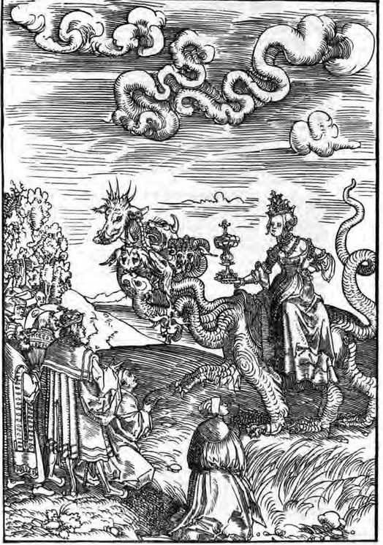
Lucas Cranach the Elder, Babylon (1522)

3. New Jerusalem (Rev 21:9–22:5)
- The New Jerusalem as the antithesis of Babylon
- Three facets of the New Jerusalem:
  - A city, perfectly proportioned
  - A temple (or, more specifically, the Holy of Holies)
  - A garden, containing the river and tree of life
- Some details of the New Jerusalem
- The New Jerusalem and the life of the Church

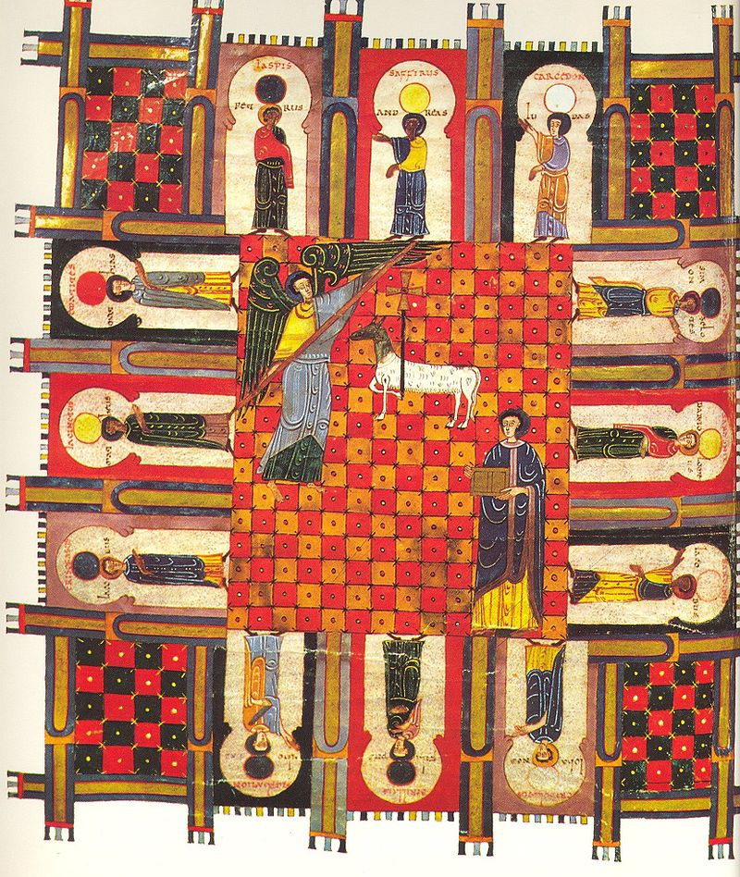
Facundus Beatus, The New Jerusalem (1047; in the public domain)

‘And how we watch and struggle, and now we live in hope,
And Zion in her anguish with Babylon must cope;
But He whom now we trust in shall then be seen and known,
And they that know and see Him shall have Him for their own.’
(‘Jerusalem the Golden,’ trans. John Mason Neale).

Now, in the meantime, with hearts raised on high,
We for that country must yearn and must sigh;
Seeking Jerusalem, dear native land,
Through our long exile on Babylon’s strand’ (Peter Abelard).

